Section I: Scenario Demographics

Scenario Title: | ASA overdose
Date of Development: | 05/02/2015 (DD/MM/YYYY)
Target Learning Group: | Juniors (PGY 1 – 2) Seniors (PGY ≥ 3) All Groups

Section II: Scenario Developers

Scenario Developer(s): | Donika Orlich
Affiliations/Institution(s): | McMaster University
Contact E-mail (optional): | Donika.orlich@medportal.ca

Section III: Curriculum Integration

Learning Goals & Objectives
Educational Goal: | To expose learners to a febrile, altered patient resulting from ASA toxicity.
CRM Objectives: | - Demonstrates situational awareness by avoiding fixation error and re-assessing and re-evaluating a changing clinical picture  - Adequately utilizes resources through early call for help and appropriate delegation of tasks  - Performs a tailored and appropriately brief goals of care discussion with the family of a critically unwell patient
Medical Objectives: | - Initiates broad work-up of the febrile altered patient  - Identifies AG metabolic acidosis on critical VBG/lytes  - Administers appropriate early treatment for ASA toxicity  - Employs a tailored approach to intubation and ventilator settings  - Recognizes the need for dialysis

Case Summary: Brief Summary of Case Progression and Major Events
The learner will be presented with an altered febrile patient, requiring an initial broad work-up and management plan. The learner will receive a critical VBG report of severe acidosis, hypoglycemia and hypokalemia, requiring management. Following this, the rest of the blood work and investigations will come back, giving the diagnosis of salicylate overdose. The patient’s mental status will continue to decline and learners should proceed to intubate the patient, anticipating issues given the acid-base status. The learner should also initiate urinary alkalinization and make arrangements for urgent dialysis.

References
Marx, J. A., Hockberger, R. S., Walls, R. M., & Adams, J. (2013). Rosen's emergency medicine: Concepts and clinical practice. St. Louis: Mosby.

Section IV: Scenario Script

A. Scenario Cast & Realism
Patient: | Computerized Mannequin |  |  |  |  | Realism:  Select most important dimension(s) |  |  | Conceptual
 | Mannequin |  |  |  |  |  |  |  | Physical
 | Standardized Patient |  |  |  |  |  |  |  | Emotional/Experiential
 | Hybrid |  |  |  |  |  |  |  | Other:
 | Task Trainer |  |  |  |  |  |  |  | N/A
Confederates | Brief Description of Role
Daughter | Provides collateral history. Last seen well 3 days ago. Full code. After results are back, confirms recent stressor being left at alter for 2nd marriage
Nurse | To assist at bedside, cue learners to patient’s respiratory status and seizure PRN
B. Required Monitors
EKG Leads/Wires |  |  | Temperature Probe |  |  |  | Central Venous Line
NIBP Cuff |  |  | Defibrillator Pads |  |  |  | Capnography
Pulse Oximeter |  |  | Arterial Line |  |  |  | Other:
C. Required Equipment
Gloves |  |  | Nasal Prongs |  |  |  | Scalpel
Stethoscope |  |  | Venturi Mask |  |  |  | Tube Thoracostomy Kit
Defibrillator |  |  | Non-Rebreather Mask |  |  |  | Cricothyroidotomy Kit
IV Bags/Lines |  |  | Bag Valve Mask |  |  |  | Thoracotomy Kit
IV Push Medications |  |  | Laryngoscope |  |  |  | Central Line Kit
PO Tabs |  |  | Video Assisted Laryngoscope |  |  |  | Arterial Line Kit
Blood Products |  |  | ET Tubes |  |  |  | Other: Dialysis catheter kit
Intraosseous Set-up |  |  | LMA |  |  |  | Other:
D. Moulage
Old man mask.

E. Approximate Timing
Set-Up: |  | 20 min |  | Scenario: | 15 min |  |  | Debriefing: |  | 30 min

Section V: Patient Data and Baseline State

A. Clinical Vignette: To Read Aloud at Beginning of Case
You are working at a community hospital. The triage nurse comes to tell you that they have just put an 82 year-old male in a resuscitation room. He was found unresponsive by daughter and was brought in by EMS. In triage he was profoundly altered, febrile and hypotensive. His daughter is in the room with him.
B. Patient Profile and History
Patient Name: John Valentine |  |  |  |  |  | Age: 82 |  |  |  |  |  |  |  | Weight: 75 kg
Gender: M F |  |  |  |  |  | Code Status: Full
Chief Complaint: Altered LOC
History of Presenting Illness: Last seen well 3 days ago. He was not answering the phone so daughter went to his house today and found him unresponsive in his bed. Previously well. Was supposed to get re-married about a week ago, but she left him at the altar. He’s been pretty down since then, but nothing unexpected.
Past Medical History: |  | HTN |  |  |  |  | Medications: |  |  |  |  | Metoprolol 50mg BID
 |  | Dyslipidemia |  |  |  |  |  |  |  |  |  | Crestor 40mg OD
 |  | Hypothyroidism |  |  |  |  |  |  |  |  |  | Levothyroxine 100mcg OD
 |  | Depression |  |  |  |  |  |  |  |  |  | Citalopram 20mg OD
Allergies: None
Social History: Lives alone. Non-smoker. Non-drinker
Family History: Nil
Review of Systems: |  | CNS: |  |  | Daughter unaware of previous complaints
 |  | HEENT: |  |  | “
 |  | CVS: |  |  | “
 |  | RESP: |  |  | “
 |  | GI: |  |  | “
 |  | GU: |  |  | “
 |  | MSK: |  |  | “ |  |  |  |  |  |  |  | INT:
C. Baseline Simulator State and Physical Exam
No Monitor Display |  |  |  | Monitor On, no data displayed |  |  |  |  |  |  | Monitor on Standard Display
HR: 122/min |  |  | BP: 83/60 |  |  |  |  | RR: 35/min |  |  |  |  |  |  | O₂SAT: 92 % NRB
Rhythm: NSR |  |  | T: 38.6ºC |  |  |  |  | Glucose: 3.1mmol/L |  |  |  |  |  |  | GCS: 9 (E3 V2 M4)
General Status: Unresponsive on bed
CNS: | Opens eyes to voice. Confused. Withdraws to pain bilaterally.
HEENT: | No signs HI. No meningismus. Pupils 2 mm fixed bilaterally.
CVS: | No murmur. No edema.
RESP: | Agonal respirations. Notable tachypnea and work of breathing, bilateral crackles.
ABDO: | Soft. Normal bowel sounds.
GU: | Nil
MSK: | No signs trauma. |  |  |  |  |  |  |  | SKIN: | Dry

Section VI: Scenario Progression
Scenario States, Modifiers and Triggers
Patient State | Patient Status | Learner Actions, Modifiers & Triggers to Move to Next State
1. Baseline State  Rhythm: NSR  HR: 122/min  BP: 83/60  RR: 35/min  O₂SAT: 93% NRB  T: 38.6ºC | GSC 9  (E3 V2 M4)  When asked re: goals of care, daughter indicates “would want everything done”  RN to cue re: high resp rate, increased WOB | Learner Actions  - IV, O2, monitors  - Fluid bolus  - Check glucose (3.1) and replace with D50  - Tox + Cardiac + Sepsis + CK + TSH blood work  - ECG  - Portable CXR  - Broad spectrum Abx  - Obtain collateral history and goals of care from daughter  - CT Head when stable | Modifiers  Changes to patient condition based on learner action  - D50 given no effect on GCS  - 1st fluid bolus BP 95/70, HR 108  - 2nd bolus BP 100/78, HR 97  Triggers  For progression to next state  - Capillary glucose not checked by 3 minutes 3. Seizure  - Fluids given, labs ordered, glucose corrected, or 5 min. 2. VBG Back
2.VBG Back  Rhythm: NSR  HR: 100/min  BP: 97/72  RR: 40/min  O₂SAT: 90 % NRB | Give VBG ONLY at onset of state. | Learner Actions  - Treat hypokalemia  - Recheck glucose (3.2)  - Start D5 infusion  - Recognize AG metabolic acidosis | Triggers  - Capillary glucose not rechecked by 3 mins 3. Seizure  - Lytes, glucose corrected 4. Rest of Labs Back
3. Seizure  Rhythm: NSR  HR: 150/min  BP: 100/75  RR: 18/min  O₂SAT: 85 % | Patient begins to seize (RN to cue) | Learner Actions  - Check glucose (1.9)  - D50 bolus  - IV benzodiazepine | Modifiers  Triggers  - From state 1. & glucose corrected 2. VBG back  - From state 2. & glucose corrected 4. Rest of Labs back
4. Rest of Labs Back  Rhythm: NSR  HR: 95  BP: 95/65  RR: 42  O2: 85% NRB | GCS 5, patient vomiting. (RN to prompt that patient not protecting, more somnolent)  Give remaining lab results at onset of state. | Learner Actions  - Update daughter  - Initiate urinary alkalization  - Nephrology & ICU Consult  - Intubation with plan re: acidosis (NaHCO3 before)  - Post-intubation care (set vent to high RR, sedation, CXR)  - Call Poison Control | Modifiers  Triggers  - Considers acidosis with intubation plan END CASE PRN  - Does not consider acidosis in intubation plan (does not match vent to RR) 5. VF Arrest
5. VF Arrest | Patient loses pulse with VF rhythm x 3 rounds | Learner Actions  - Good quality CPR  - Shock VF  - Epinephrine  - Amiodarone | Triggers  - 15 min End Case PRN

Section VII: Supporting Documents, Laboratory Results, & Multimedia

Laboratory Results
Na: 135 | K: 2.0 |  |  |  | Cl: 100 |  | HCO₃: 10 |  | BUN: 20 |  | Cr: 580 |  | Glu: 3.3
Ca: 2.58 |  |  |  | Mg: 0.65 (low) |  |  |  | PO₄: 0.80 |  | Albumin: 12
AG = 27 |  |  |  | OG = 7 |  |  |  | CK: 500 |  |  |  | TSH: 0.4 (normal)
VBG |  | pH: 7.05 |  |  |  | PCO₂: 30 |  | PO₂: 90 |  | HCO₃: 8 |  |  | Lactate: 10
Troponin: 7 |  |  |  |  |  | INR: 3.3 |  |  |  | PTT: 40
WBC: 18 |  |  |  | Hg: 120 |  |  |  | Hct: 0.52 |  | Plt: 330
AST: 300 |  |  | Tylenol: <0.15 |  |  |  | EtOH: <2 |  |  | ASA: 7.6 |  |  | Osm: 300

Images (ECGs, CXRs, etc.)
Hypokalemia ECG  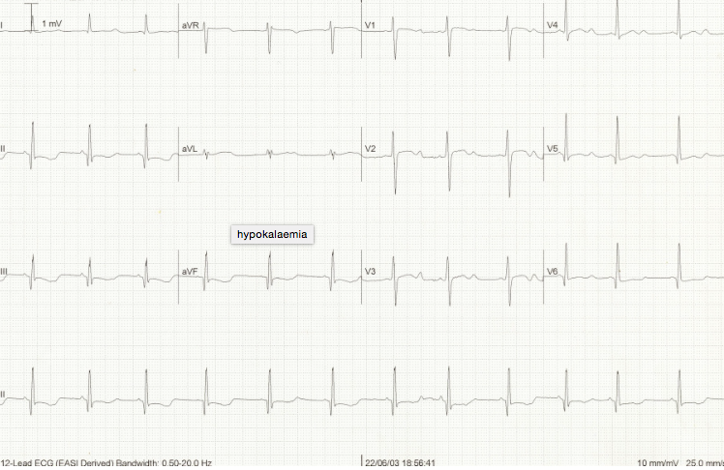  ECG source: https://lifeinthefastlane.com/ecg-library/basics/hypokalaemia/ | Pre-Intubation CXR- ARDS  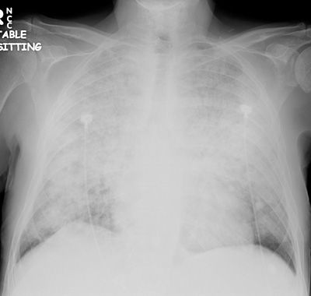  CXR source: http://www.radiology.vcu.edu/programs/residents/quiz/  pulm_cotw/PulmonConf/09-03-04/68yM%2008-03-04%20CXR.jpg
Post- Intubation CXR- ARDS
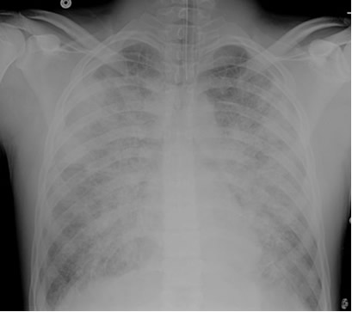
CXR source: http://courses.washington.edu/med620/images/
mv_c3fig1.jpg
Ultrasound Video Files (if applicable)
Abdomen: no FF | Aorta: no AAA
Cardiac: no PCE
Section VIII: Debriefing Guide

General Debriefing Plan
Individual | Group |  | With Video | Without Video
Objectives
Educational Goal: |  | To expose learners to a febrile, altered patient resulting from ASA toxicity.
CRM Objectives: |  | - Demonstrates situational awareness by avoiding fixation error and re-assessing and re-evaluating a changing clinical picture  - Adequately utilizes resources through early call for help and appropriate delegation of tasks  - Performs a tailored and appropriately brief goals of care discussion with the family of a critically unwell patient
Medical Objectives: |  | - Initiates broad work-up of the febrile altered patient  - Identifies AG metabolic acidosis on critical VBG/lytes  - Administers appropriate early treatment for ASA toxicity  - Employs a tailored approach to intubation and ventilator settings  - Recognizes the need for dialysis
Sample Questions for Debriefing
- What is your differential diagnosis for the altered and febrile patient?
- What is on the differential diagnosis for an AG metabolic acidosis? For an Osmolar Gap acidosis? For a double gap acidosis?
- What acid-base disturbances are seen with ASA overdose? Why?
- What are the metabolic effects of an ASA overdose?
- What is the toxic dose of ASA? When do we do levels?
- List 3 causes of SOB/tachypnea in the ASA toxic patient
- What is the goal urine pH and serum pH during urinary alkalinization?
- What are the indications for urinary alkalinization?
- What are the indications for dialysis?
Key Moments
Initial code discussion and update with reconsideration of code status given OD diagnosis
Initiate urinary alkalinization
Recognize need for dialysis

